**DSA Assignment – 16h July**

**Name – Karan Joshi**

**Roll No. – 23/11/EC/036**

**Leetcode Id – Karan_Joshi068048**

**Geeksforgeeks Id – wwwjoshikaran3424**

**Github Repo Link -** [**https://github.com/KaranJoshi101/urban-octo-robot/**](https://github.com/KaranJoshi101/urban-octo-robot/)

DSA-Section -

Question 1: Binary Tree Right Side View

Platform: LeetCode

Problem Link: <https://leetcode.com/problems/binary-tree-right-side-view/description/>

Submission Screenshot:

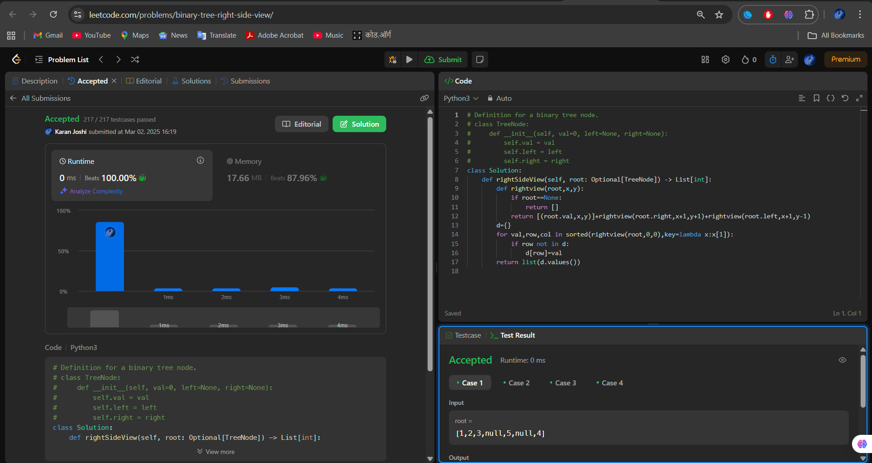

Question 2: Path Sum II

Platform: LeetCode

Problem Link: <https://leetcode.com/problems/path-sum-ii/description>

Submission Screenshot:

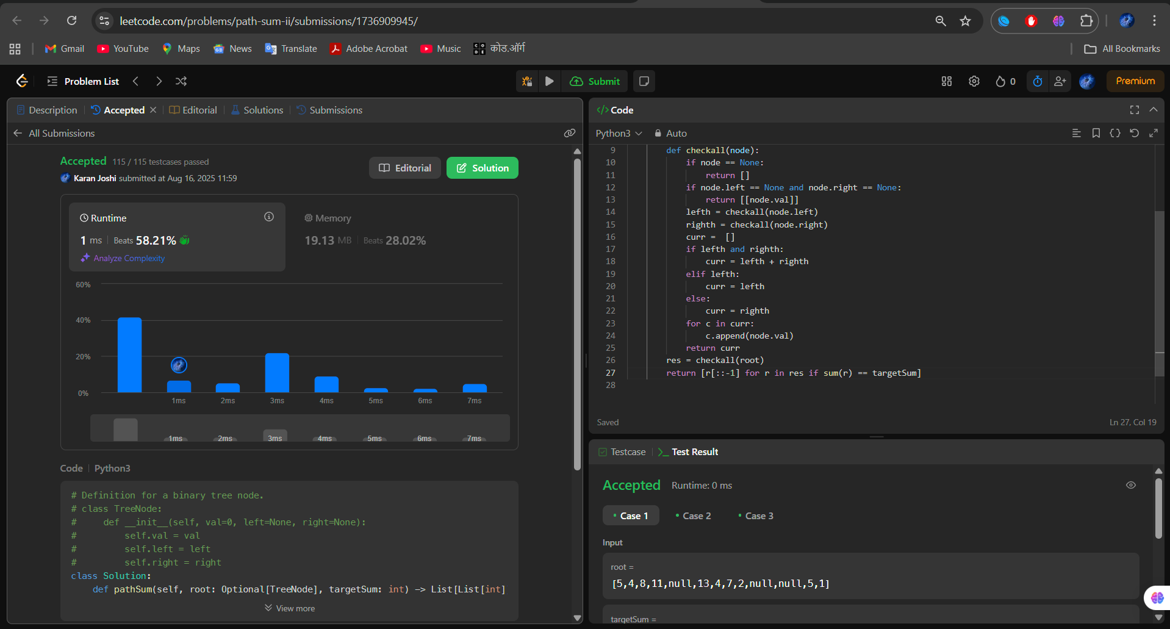

Question 3: Lowest Common Ancestor

Platform: LeetCode

Problem Link: Lowest Common Ancestor of a Binary Tree – LeetCode

Submission Screenshot:

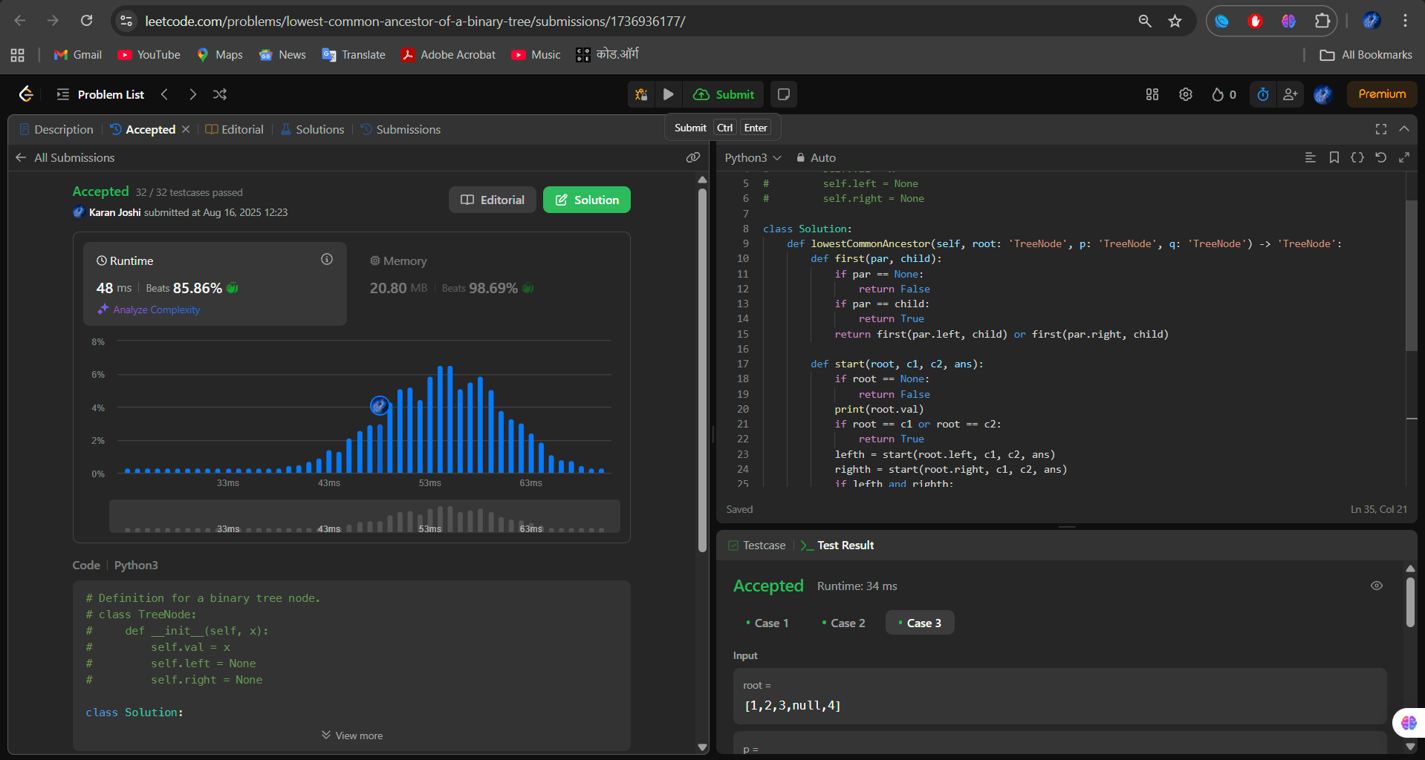

Question 4: Kth Smallest Element in BST

Platform: LeetCode

Problem Link: Kth Smallest Element in a BST - LeetCode

Submission Screenshot:

